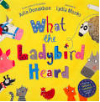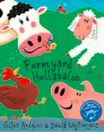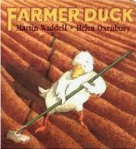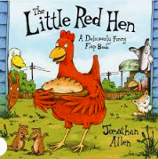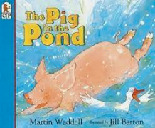

In **Literacy** we will;

Be involved in shared writing experiences where the children will be excited and enthused to write.   
Continue our Read Write Inc phonics learning – looking at Set 1, including digraphs (sh, th, ch, ng, nk, etc.) and Set 2 sounds. Children will be using Fred Fingers to spell CVC words.  
Children will have more opportunities to capture their own ideas for both fiction and non-fiction texts. Children will develop their own narratives and explanations. Children will be encouraged to read longer words frequently with increasing fluency.

In **Communication and Language** we will;   
**Talk it through**Settling in activities will continue encouraging children to express their needs and wants. Children will be encouraged to use language well   
They will be asking how and why questions. They will continue to discover passions.   
Retell a story with story language and begin to invent their own story and talk it. They will use FANTASTICs to improve their ideas. They will ask questions to find out more and to check they understand what has been said to them.   
Children will describe events in detail using time connectives. Listen to and talk about stories to build familiarity and understanding, learn rhymes, poems and songs.   
Exploring artefacts from the story and describe what they are and what they could be used for.

In **Understanding the World** we will;   
Learn about the Easter Story.  
Be understanding of what makes a good friend.   
Develop our understanding of the seasons and weather.   
Explore similarities and difference between animals from around the world to those on a farm.

In **Expressive Arts and Design** we will;

Create artwork themed around The Seasons Art.

Children will be encouraged to select the tools and techniques, they need to assemble materials that they are using.

Children will be designing homes for various farm animals.

In our **Physical Development** learning we will;   
Experiencing a variety of fine motor activities to develop muscle tone to support writing. Form recognisable letters with most correctly formed. Use a variety of tools within the provision – they will hold pencil effectively with comfortable grip. Complete independent writing and drawing activities. Continue to work on balance and big movement activities. Children will be participating in team games.

**Significant Author**We will explore books by **Martin Waddell** this half term.

In our **Personal, Social and Emotional** learning we will;

* Children will begin to know that there are different festivals.
* Begin to understand themselves as individuals and compare similarities and differences between themselves and others.
* Continue to make good friendships.
* Co-operate and resolve conflicts with support.

In **Maths** we will;   
Count forwards and backwards up to and within 10. Explore length and height, measuring using non-standard units of measure. They will be counting, comparing and ordering these numbers. They will be ordering and comparing numbers to 10. Children will be exploring key events and changes over time. They will also begin to understand to concepts of number bonds to 10.

**Extra Opportunities this half term…**

* Easter Bonnet Parade ***More curriculum information***

***can be found on the website***

In this topic children will be exploring the farm. Children will be discovering more about the animals living on a farm, including the life cycles of different animals. Children will be immersed in reading for International Book day and Reading week. The children will also go on an experience day to a local farm. Children will focus on inspirational women in society and within their own experiences.

This Half Term’s school value is   
**Care**

The Farm

Race Leys   
Infant School

**Reception   
Spring 2nd Half Term**