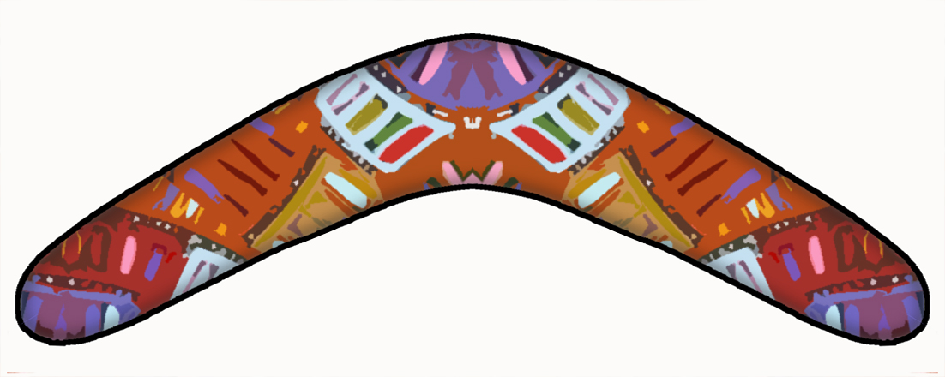
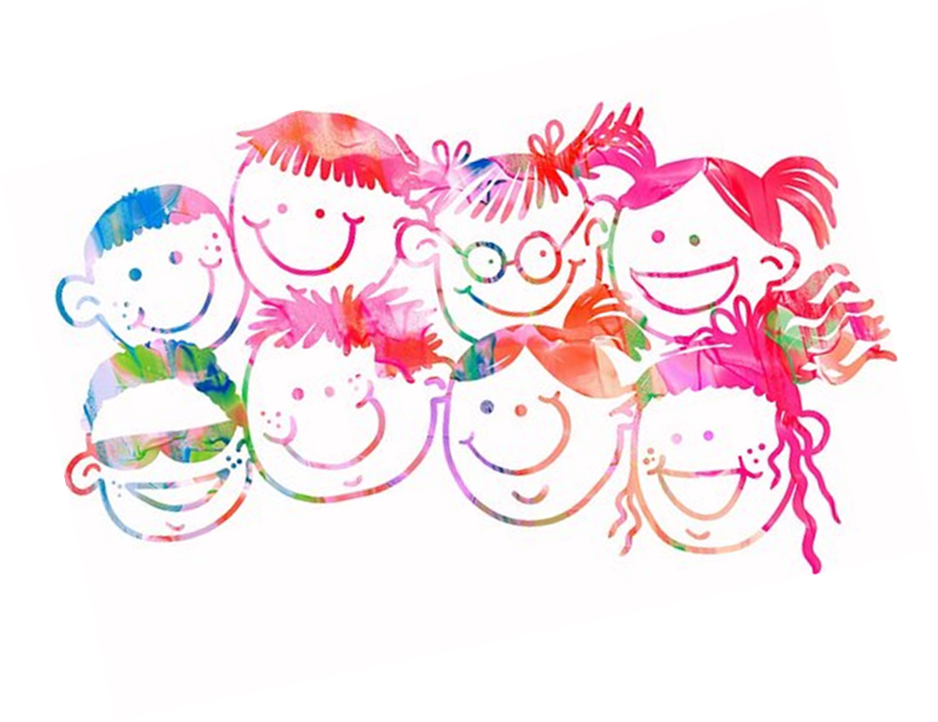

Primary Resilience Group

BOOMERANG

Adults Pack

Welcome to Boomerang!
The aim of this pack is to keep parents and carers informed of what your child will be doing during the Boomerang group and how you can support them at home. The aim of Boomerang is to support children to learn about emotions and to discover some tools that may help them to manage difficult emotions that we experience as part of everyday life (such as anger or stress). It is important to hold in mind that every child will develop different skills and techniques at different speeds.
This booklet provides an overview of each session. The main aims of each session are outlined to share with you what we hope children will learn and achieve during each week. You will also find a brief explanation of the activities that your child will have taken part in during the session, as well as the homework task that they were set. This pack includes weekly tips on how you can build on the strategies being taught and how you can further support your child at home. By helping your child to practise the techniques regularly at home, the more likely they will get the most out of this programme and improve their resiliency skills.
The Boomerang five week programme will cover:
Week 1 – Naming and noticing emotions.
Week 2 – Our thoughts, feelings and behaviours.
Week 3 – Leaning on others and problem solving.
Week 4 – Friendships and being kind to ourselves.
Week 5 – Relaxation and looking after ourselves.

Session one: Emotions and how to spot them

Aims of the session
- To know that feelings are a normal part of being human – learning to name them helps you share them with others.
- To learn about how your body gives you clues to help you know what you are feeling.
This is the first week that your child has been in the Boomerang group. It may have been a really exciting day for your child and it may also have been a little bit scary. Both of these feelings are okay, and the best thing you can do to support your child is to give them plenty of opportunity to talk with you about it. Make sure you praise your child for trying and engaging in the Boomerang group, and make some time to show an interest in what they have learnt each week. Doing these small things will be supportive for your child throughout their experience of the Boomerang group.

This weeks activities
This week, your child has been learning about emotions, and all the different ways we can describe how we feel. They focused on looking at 5 main emotions:
- Joy
- Sadness
- Disgust
- Fear
- Anger
They watched a video clip from ‘Inside out’ to help them understand the different emotions, and how they can all exist inside one person.
After learning about different types of emotion, we looked at how we can notice them in others. Often children can understand something better when we consider it happening to a friend rather than imagining it actually happening to them. We practiced acting out emotions and describing what they look like in other’s behaviour.

Homework
This week your child has been asked to try and take notice of their emotions and any signs that they might be feeling certain emotions. If you can, try to encourage your child to complete this homework, or even if you notice them experiencing one of the 5 emotions above, encourage them to tell you or write it down and bring it to their next Boomerang session.

Session two: Our Thoughts, Feelings and Behaviours

Aims of Session
- To understand our body’s normal response to stress.
- To know that thoughts are linked to how we feel and what we do.
- To know that adults can help me with my thoughts.

This weeks activities
This week we looked at how our bodies react to stress. When we see somethingthat scares us, or makes us very nervous and stressed, our bodies can go into fight, flight, or freeze mode. This is a natural reaction that once protected us from danger.

In order to get ready to FIGHT, our body releases a hormone to give us energy that makes us feel strong enough to attack back. This is why our muscles feel tense.
Another way to deal with stress might be to run away – so our bodies release a chemical called adrenaline (making us sweaty) to
help us to
FLIGHT.
If we don’t fight, or flight, we might FREEZE! This reaction has evolved over time because it’s harder for predators to notice us when we are not moving! We might feel
faint or
dizzy.
We also looked at our thoughts, feelings, and behaviours and how they are all linked up. Our thoughts can change how we feel. For example, a child may think he/she is not going to do so well in their SATS, then they might start to feel nervous and worried. That nervous and worried feeling may make them feel sick, and they might not want to go to school in order to avoid the situation. However, not going to school may only make their thoughts about the test worse as they would miss lessons and get behind.
BEHAVIOUR
THOUGHTS
FEELINGSS
It can be difficult for your child to know the difference between a thought and a feeling. If they need a reminder it is helpful to think about it like this: thoughts are like the words you say to yourself in your head, and feelings come from the heart (they are often one word e.g. happy, sad, angry, worried).
Homework
This weeks homework is to think about a time when our bodies went into fight, flight, or freeze, and try to think about what we were thinking and feeling at the time. This can be hard, so it would be great if an adult could help.

Session three: Leaning on others and problem solving

Aims of session
- To know that there are people we can lean on for help.
- To know what we can do if we have a problem.

This weeks activities
This week we have been thinking about the people in our lives that are here for us, and that we can lean on when we need help. We may have made some crafts or completed work sheets to help remind us of who we can go to when we need support. This can be friends, people at school or at clubs, or members of our family. It is important to have people in our lives that we can turn to when we need support.
We also looked at problem solving. At such a young age, learning to problem solve is important, but children will need support from an adult to do this. Today we practiced using five step problem solving. Here are the five steps:

- How do you feel? - Identify how the problem is making them feel. You could use emojis to help with this. Practise putting this into words: “I feel…”
- What’s the problem? - Break down what the problem is. Practise putting into words: “I have a problem I need help to solve it. The problem is…”
- Solutions – what could I do? - Generate as many solutions as they can think of and write them all down (no idea is a silly idea).
- What would happen? Pros and cons of each idea – List the pros and cons for each solution.
- Try out your solution – Select which solution they will try and give it a go.

Homework
Homework this week is to think about a problem your child has or might have had in the past. We hope that they will come to you for help with this. Try to support your child through the five steps to solving their problem, if you are able. Remember to praise them on asking for help and working through the problem with your help.

Session four: Friendships and being kind to yourself

Aims of session
- To understand what a good friend might think, say and do.
- To understand how we can be a good friend to ourselves and celebrate what we are good at.

This weeks activities
This week we thought about what makes a good friend. We talked about what a good friend might think, say and do. Friendship is about being kind and thoughtful which is not always easy to do. Sometimes your child might struggle with elements of being a good friend, and that’s okay. Friendships are built on honesty and trust, and it is important that if your child suffers a rupture in a friendship – with a friend, or with family member - that time is taken to repair this friendship.
Once we know how to be good friends to others, we can try to be good friend to ourselves. Even adults struggle to be a friend to themselves. As human beings, we often focus on the things we cannot do or things we want to improve and forget to remind ourselves of things we are good at or our qualities. During this session, the children were asked to make something that would encourage them to be nice to themselves – this may have been an encouraging statement on a post card, or working with their group to make a large display for the school about being kind to yourself.
The last activity focused on building self-esteem. We may have worked in groups to increase one another’s self esteem with kind statements, or spent some time thinking about the things we are good at and our achievements. It may be that you can think of some of the things your child does or has achieved that have made you proud – today would be a great day to remind them of this!
My best quality is….
I’m proud of myself because…

I’m kind!

Homework
Your child will have left the Boomerang group with a positive quality of a friend on a slip of paper. This week their task is to practise this quality. It could be being a good listener, or to share when they play with others. You can encourage them to do this by asking about it, and reminding them of it during the week.

Session five: Relaxing and feeling good

Aims of Session
- Share and learn good ways to relax.
- Start to make my own ‘feel good’ box.

This weeks activities
We started off this session by trying out some relaxation techniques. If you want to do some additional relaxation with your child, there are some links to online relaxation resources at the end of this pack. Your child may have tried lots of different ways to relax, but it is important to remember that not all of them will work for every child. Finding a way to relax that works well for your child can be really beneficial when they are in times of stress. This could be using the relaxation techniques used in Boomerang or other things like having a bath, or listening to a certain genre of music.
We also started to make something to remind us of ways to look after our emotional wellbeing and feel good. This may be a box, bag, or collage containing things that your child thinks will help them to feel good. Your child will have been encouraged to include things that remind them of the people they can lean of for support – as these people play a key role in protecting the wellbeing of any child and young person.
Your child will be encouraged to add to the box or collage at home. Some ideas of things to include could be…
- Pictures of loved ones
- Kind words to make you smile
- A list of their top ways to relax
- A puzzle to keep you distracted
- Things that smell or feel nice
- And so much more!
We recommend that children use this box with the support of an adult. The aim of the box is not to get them to cope with really difficult situations alone, but instead to encourage them to do things to look after their emotional wellbeing (just like we do things to look after our physical wellbeing).
Goodbye to Boomerang
This session we said our goodbyes to the Boomerang group. Remember to praise your child on taking part in the group, and check in with how they feel – will they miss the group? Did they make any new friends?
We encourage you to keep talking to your child about the skills learnt in the Boomerang group, including supporting them to develop problem solving skills, make and maintain friendships, and think about looking after their minds as well as their bodies! Opening up these conversations is key to making sure your child always feels like they have someone to lean on!

Helpful Resources:

http://www.moodcafe.co.uk/
This website provides a range of techniques to help reduce anxiety related issues as wells as providing practical information regarding mental health.
http://www.innerhealthstudio.com/relaxation-scripts-for-children.html
This webpage provides a variety of relaxation scripts that can help your child reduce stress levels as well as aiding in them getting more restful sleep.
http://www.youtube.com
By searching ‘Relaxation for Children’ you will find a wide variety of videos that include peaceful music and relaxation scripts (please take care to check videos before playing them to children).
http://www.kidsplayandcreate.com/
This website contains many fun activities for children that can help them build self-esteem.
https://www.bbc.co.uk/cbbc/joinin/shy-kids-guide-to-making-friends
for information to look at with your child about how to make friends – and is great from prompting tehm to remember all the ways we can be good friend to others

